Experiment No: 1

Title
C Program to Display Right-Angle Triangle, Diamond Shape with Numbers, and Pyramid with Asterisks

Aim
To write a C program that prints different patterns, namely:
- Right-Angle Triangle with numbers
- Diamond Shape with numbers
- Pyramid with asterisks

Objectives
- To understand and apply nested loops in C.
- To practice pattern generation using loops and conditional logic.
- To improve skills in programming logic development.
- To demonstrate formatting and alignment in console output.

Requirements
- Software: Any C compiler (e.g., GCC, Turbo C, Code::Blocks, Dev-C++, or OnlineGDB).
- Hardware:
  - A computer system with minimum 2GB RAM
  - Processor: Intel/AMD compatible
  - Operating System: Windows/Linux/Mac

Description
In this program, we generate three different patterns using nested loops:
- Right-Angle Triangle with Numbers
  - Each row prints numbers from 1 up to the row number.
- Diamond Shape with Numbers
  - The upper half prints increasing rows of numbers aligned symmetrically.
  - The lower half mirrors the upper half.
- Pyramid with Asterisks
  - Prints a centered pyramid of asterisks where each row contains an odd number of stars.
These patterns are generated using nested for-loops, where one loop controls rows, another controls spaces, and the innermost loop prints numbers or stars.

Algorithm

1. Right-Angle Triangle with Numbers
- Start
- Input number of rows n.
- For each row i from 1 to n:
  - Print numbers from 1 to i.
- End

2. Diamond Shape with Numbers
- Start
- Input number of rows n.
- For upper half (i = 1 to n):
  - Print spaces (n - i).
  - Print numbers from 1 to i.
- For lower half (i = n-1 down to 1):
  - Print spaces (n - i).
  - Print numbers from 1 to i.
- End

3. Pyramid with Asterisks
- Start
- Input number of rows n.
- For each row i from 1 to n:
  - Print spaces (n - i).
  - Print asterisks (2*i - 1).
- End

Conclusion
- The program successfully prints three different patterns using nested loops.
- This exercise improves understanding of loop control, formatting, and alignment in C.
- It demonstrates how the same logical structure (nested loops) can be adapted to generate different shapes.

Program to implement pattern using C:
#include <stdio.h>
void rightAngleTriangle(int n) {
printf("\nRight-Angle Triangle with Numbers:\n");
int i,j;
for ( i = 1; i <= n; i++) {
for ( j = 1; j <= i; j++) {
printf("%d ", j);
}
printf("\n");
}
}
void diamondWithNumbers(int n) {
printf("\nDiamond Shape with Numbers:\n");
// Upper half
int i,s,j;
for ( i = 1; i <= n; i++) {
for ( s = 1; s <= n - i; s++) {
printf(" ");
}
for ( j = 1; j <= i; j++) {
printf("%d ", j);
}
printf("\n");
}
// Lower half
for ( i = n - 1; i >= 1; i--) {
for ( s = 1; s <= n - i; s++) {
printf(" ");
}
for ( j = 1; j <= i; j++) {
printf("%d ", j);
}
printf("\n");
}
}
void pyramidWithStars(int n) {
printf("\nPyramid with Asterisks:\n");
int i,s,j;
for ( i = 1; i <= n; i++) {
for ( s = 1; s <= n - i; s++) {
printf(" ");
}
for ( j = 1; j <= (2 * i - 1); j++) {
printf("*");
}
printf("\n");
}
}
int main() {
int n;
printf("Enter number of rows: ");
scanf("%d", &n);
rightAngleTriangle(n);
diamondWithNumbers(n);
pyramidWithStars(n);
return 0;
}

Output:
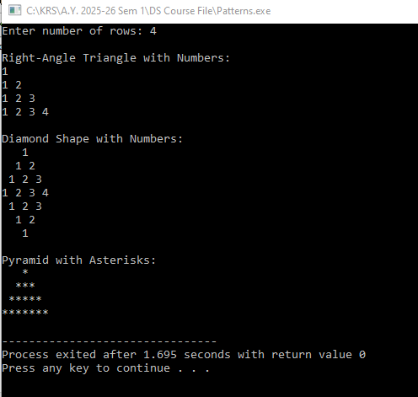

Need of This Experiment in Real Life
- Develops Logical Thinking
  - Students learn how to break a problem into smaller steps.
  - Helps in designing algorithms used in software and embedded systems.
- Understanding Loops
  - Reinforces the use of for, while, and nested loops.
  - Loops are widely used in automation, robotics, signal processing, and data analysis.
- Improves Decision-Making Skills
  - Uses conditional statements (if-else) to control output.
  - Similar logic is used in traffic light controllers, industrial automation, and smart devices.
- Strengthens Problem-Solving Ability
  - Encourages students to think about row-column relationships and program flow.
  - Useful for developing efficient software solutions.
- Foundation for Graphics and Game Development
  - Pattern generation is the basic concept behind drawing shapes, computer graphics, animations, and game design.
  - Pixel placement on a screen follows similar row-and-column logic.
- Data Representation
  - Number patterns help students understand matrices and two-dimensional arrays.
  - These concepts are used in image processing, artificial intelligence, and scientific computing.
- Debugging Skills
  - Small mistakes in loops or conditions change the entire pattern.
  - Helps students learn systematic debugging and testing techniques.

Real-Life Applications
- LED display boards – Controlling the ON/OFF pattern of LEDs.
- Digital image processing – Images are represented as rows and columns of pixels.
- Computer graphics – Drawing shapes, icons, and animations.
- Robotics and automation – Repetitive control operations using loops.
- Game development – Creating maps, grids, and object placement.
- Embedded systems – Generating repetitive control signals for electronic devices.
- Report generation – Formatting tables and structured output in software applications.
Experiment Variation | Skills Developed | Real-Life Need / Application
1. Right-Angle Triangle with Asterisks (*) | Nested loops, row-column logic | Used in generating simple graphical patterns, text formatting, and understanding screen rendering.
2. Inverted Triangle | Reverse looping, conditional logic | Used in countdown timers, reverse data processing, and sorting algorithms.
3. Inverted Pyramid | Reverse iteration, pattern symmetry | Used in animation effects, graphical transformations, and display systems.
4. Full Diamond with Asterisks | Combining multiple loops, symmetry | Similar concepts are used in image processing, CAD software, and computer graphics.
5. Floyd's Triangle | Increment operators, sequence generation | Used in generating IDs, serial numbers, and numerical simulations.
6. Pascal's Triangle | Mathematical computation, combinatorics | Applied in probability, binomial expansion, cryptography, and data science.
7. Hollow Pyramid / Hollow Diamond | Conditional statements inside loops | Used in CAD drawing, digital design, and geometric modeling.
8. Character (Alphabet) Patterns | ASCII values, character manipulation | Useful in text processing, encryption, compiler design, and coding systems.
9. Zig-Zag or Wave Patterns | Complex loop logic | Applied in signal processing, waveform generation, and graphical simulations.

Basic Questions
- What is the objective of this experiment?
- What is a pattern program?
- Why are pattern programs important in C programming?
- Which programming concepts are used in this experiment?
- What is a nested loop?
- Why are nested loops required for pattern printing?
- What is the difference between a for loop and a while loop?
- What is the role of the outer loop?
- What is the role of the inner loop?
- Why do we use printf() in pattern programs?

